# Home Page

## MainImage (World-Class Solutions…):



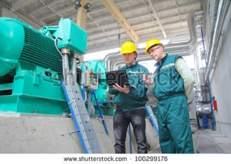#1

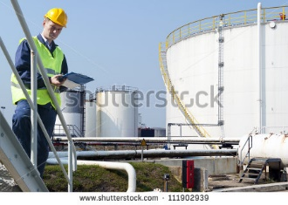



#2

## FeaturedImage (A Trusted Partner…):

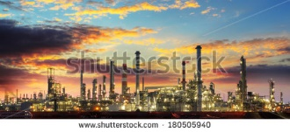

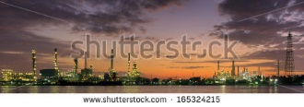#1

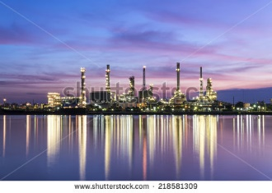#2



## SecondaryImage (DST is Committed…):

High-quality picture of the DST team, smiling and ready to help! Take outside for optimal lighting.

#1



…..Or……









## AssemblyThumbnail:

## Controlsthumbnail:

## DataThumbnail:

## Testimonial Thumbnails (x3, need content first):

# Panel & Subsystem Assembly Page

## MainImage:

## FeaturedImage:

## SecondaryImage:

## Assembly:

## Engineering:

## OSM:

## Work Examples (x4, need content first):

# Controls

## MainImage:

## FeaturedImage:

## SecondaryImage: